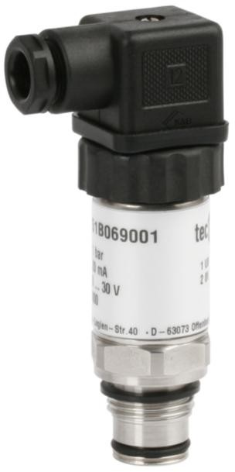
Pressure sensors for general application

with front flush diaphragm
for gauge pressure and absolute pressure Accuracy 0.25% and 0.5%

Standard output: 4 . . . 20 mA; 2-wire system
or 0 . . . 5 VDC; 3-wire system or 0 . . . 10 VDC; 3-wire system

tecsis GmbH
Carl-Legien Str. 40
D-63073 Offenbach / Main Tel.: +49(0) 69 / 5806-0
Sales National
Fax: +49(0) 69 / 5806-170
Sales International
Fax: +49(0) 69 / 5806-177
e-Mail: info@tecsis.de Internet: www.tecsis.de
DE 701 j 03/2011
p. 1 / 4
| Force | Pressure | Temperature | Switch
Description
Pressure sensors for general application are top of the range pressure transducers.

Their accuracy, reliability, resistance to corrosion and mechanical load make them suitable for all pressure measuring tasks - in production, development or in the laboratory.
The front flush pressure diaphragm avoids zones, in which medium could crystallize or residues could form, thus ensuring trouble-free pressure measurement and hygienic cleaning of the pressure sensors.

The measuring ranges, graded in accordance with EN, range from 0,1 bar to 600 bar. The case and wetted parts comprise stainless steel and are thus resistant to chemically aggressive media. With the aid of an integrated cooling element, the sensors can be supplied with medium temperatures of up to 150 °C.

For more difficult measuring tasks (e.g. hydrostatic column), two potentiometers enable the zero point andmeasuring range to be set.

The pressure sensors for general application meet the electronic magnetic compatibility (EMC) requirements to EN 61 326.

Features
- For pasty or crystallizing media
- Finely graded selection of nominal ranges according to EN
- Corrosion resistant, stainless steel design
- High overload protection
- Highly resistant to shock and vibration
- For dynamic or static measurements
- Good reproducibility
- Integrated cooling element for medium temperatures of up to 150° C

Measuring Ranges
Gauge pressure
Negative -1 . . . 0 bar to -0,1. . . 0 bar Positive 0 . . . 0.01 bar to 0 . . . 600 bar Absolute pressure 0 . . . 0.25 bar to 0 . . . 16 bar

Applications
Process engineering,
Plant and apparatus construction, Development and laboratory applications

Models: P3251

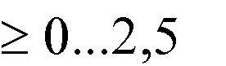
DE 701 j

p. 2 / 4
Model | P3251 |  |  |  |  |  | Option
Pressure type | negative or positive gauge pressure |  |  |  | absolute pressure |  | negative or positive gauge pressure
Output signal | 4 . . . 20 mA - 2-wire system  0 . . . 5 VDC - 3-wire system 0 . . . 10 VDC - 3-wire system |  |  |  |  |  | other signals on request
Accuracy % of F. S. 1) | 0,5 | 0,25 | 0,5 | 0,25 | 0,5 | 0,25
Ranges accord. to EN | 0 0.1 bar 2)  to  0 16 bar |  | 0 . . . 25 bar to  0 . . . 600 bar |  | 0 . . . 0,25 bar  to  0 . . . 16 bar
Sensor element | piezoresistive |  | thin film |  | piezoresistive
Repeatability | ≤ ± 0.05% of F. S.
Stability (annual) | ≤ ± 0.2% of F. S. in rated conditions
Case | Stainless steel
Pressure connection | ≤ 0…1,6 bar G 1 B; bar G 1/2 B
Wetted parts | Stainless steel
Overload limit | ≤ 16 bar 3,5 x; ≤ 600 bar 2 x;
Electrical connection | plug according to DIN EN 175301-803 form A with junction box round connector M12x1; 4-pin |  |  |  |  |  | cable outlet with 1 m cable
Power supply | 10 . . . 30 VDC (14 . . . 30 VDC for output 0 . . . 10 V)
Power consumption | output 4 . . . 20 mA: signal currency voltage output: 8 mA
Load | ≤ UB - 12 V for output (0) 4 . . . 20 mA  0.020 A  - 5 kOhm for output 0 . . . 5 V  - 10 kOhm for output 0 . . . 10 V
Temp. compens. range | 0 . . . 80 °C
Temperature influence  - Zero point  - Measuring range | ± 0.2% / 10 K 3)  ± 0.2% / 10 K
Adjustability | zero point and full scale up to ± 10%
Response time | ≤ 1 ms (within 10% to 90% of F. S.)
Protection type | IP 65 to EN 60 529 / IEC 529 |  |  |  |  |  | IP 67 for cable outlet
Emission 4) | according to EN 61 326
Interference 4) | according to EN 61 326
Electrical protection types | polarity, overload and short-circuit protection
Temperature ranges  - Storage  - Medium  - Ambient | -40 . . .100 °C  -30 . . .100 °C  -20 . . . 80 °C |  |  |  |  |  | medium temperature  -40 . . . 125 °C  integrated cooling element for temperatures  up to 150° C
Weight | approx. 0.2 kg
of F. S. = of full scale value
1) 0.25% accuracy for ranges ≥ 0.25 bar
2) For ranges < 0.1 bar: model P3275; technical data as model P3276;
wetted parts 1.4571, Si, Al and Au; only applicable for dry and non aggressive gases
3) ≥ 0 . . . 2500 bar; M 16 x 1.5 female
4) ≤ ± 0,4%/10 K for measuring ranges 0 . . . 0.1 and 0 0.16 bar
5) Declaration of conformity on request

DE 701 i

p. 3 / 4
Case
Plug according to DIN EN 175301-803 form A

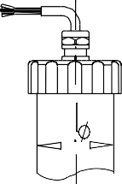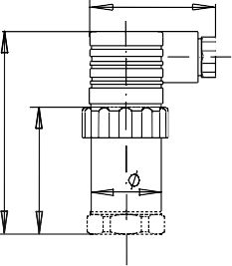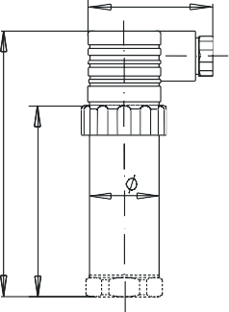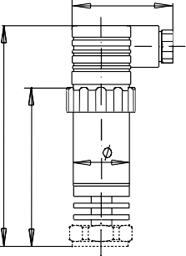Accuracy 0,5% Accuracy 0,25% with integrated cooling element cable outlet

27
48
27
48
27
48
27
82

* for long version + 22 mm
54
max. 105
75
102*
73*

Pressure connections

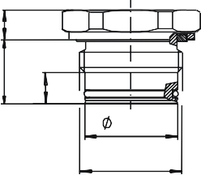G ½ B G 1 B

30 -0,1
G1
10.5
20,5 10.5
10

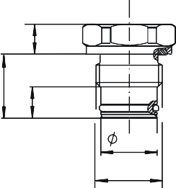A-005

18 -0.1
G1/2
20.5
10

A-004

weld-on socket or screw-in aperture

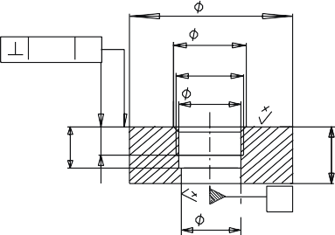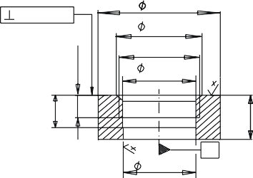G ½ G 1
0.1 A
50
21.3 -0,2

G1/2 19.4+0.1
18.2
+0.1
A
50
33.5 -0.2
G1 30.5 +0.1
30.1 +0.1
A
A
0.1
Min.10.5
Min.10.5

S-004
15 -0.2
21
15 -0.2
21
S-003

Two-wire system

DIN EN 175301-803 form A plug MIL-plug PT 02 E-10 6P 5-pin plug
UB / S+
1
3
2
0V / S-
UB / S+
F A B E D C

0V / S-
UB / S+
4 3 2
5 1
0V / S-

E-001

cable outlet M12x1

brown
UB / S+
4 3
1 2

0V / S-
UB / S+
0V / S-

green

E-011

E-035

Three-wire system

E-015

E-033

DIN EN 175301-803 form A plug MIL-plug PT 02 E-10 6P 5-pin plug
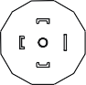
UB
S+
0V / S-
UB / S+
F A B E DC

0V / S-
UB / S+
F A B E DC

0V / S-

E-002
cable outlet M12x1
braun

E-012

E-012

UB
brown
S+
white
0V / S-
green
UB
S+

4 3
1
2
0V / S-

E-034
weiß
grün
E-017

Connection table for DIN plug or cable outlet

 | 4 . . . 20 mA  (2-wire) |  | 0 . . . 10 VDC  (3-wire)
Supply: UB+ | 1 | brown | 1 | brown
Supply: 0V | 2 | green | 2 | green
Signal: S+ | --- | -------- | 3 | white
Signal: | --- | -------- | 2 | green

Order details
- Model
- Measuring range
- Output signal
- Options

DE 701 j

p. 4 / 4

Modifications reserved

