| Force | Pressure | Temperature | Switch

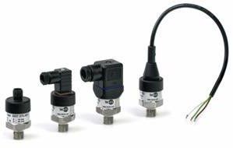Pressure sensors for industrial applications Model P3297

Non linearity 0.5% (option 0.25%)
Standard output: 4...20 mA; 2-wire
or 0...5 VDC; 3-wire or 0...10 VDC; 3-wire or 0.5 4.5 VDC; 3-wire
or 0.5 4.5 VDC ratiometric

Description

Robustness and long-term stability during operation are the strengths of this compact pressure sensor for general industrial applications.

The materials and technologies used make these sensors suitable for applications with aggerssive media. Welded connections between pressure cell and process connection require no sealing elements and make the measuring system particularly resistant to mechanical shock and vibration. The compact design makes these sensors interesting for room critical applications.

A wide variety of electrical connections and pressure ports simplifies the adaptation to different applications. The pressure sensor is internationally certified and ready for global deployment.
The pressure sensors comply with electromagnetic compatibility requirements (EMC) as per EN 61326.

Features

O Measuring range from 0...1 bar to 0...600 bar O Medium wetted parts of stainless steel
O High EMC protection according to EN 61 326 O Compact instrument size
O No internal sealing elements
O Highly resistance to shock and vibration O For dynamic or static measurements

Measuring range

Gauge pressure 0…1 bar to 0…600 bar
-1…0 bar to -1…+24 bar

Applications

Hydraulics and pneumatics Pumps and compressors Building automation
Test stand construction
Machine and apparatus construction

Model: P3297

tecsis GmbH  Carl-Legien Str. 40-44  D-63073 Offenbach / Main | Sales National | Sales International | e-Mail: info@tecsis.de | DE 708 k 02/2016
Tel.: +49(0) 69 / 5806-0 | Fax: +49(0) 69 / 5806-7788 | Fax: +49(0) 69 / 5806-7788 | Internet: www.tecsis.de | p. 1 / 4

Technical Data

Model | P3297
Pressure type | positive and negative gauge pressure absolut pressure on request
- Measuring range [bar] | 0...1 bar to 0…600 bar  -1..0 bar to -1…+24 bar
- overrange limit [bar] | x 2
- burst pressure [bar] | x 6
Sensor element | piezoresistive to 0..6 bar, thin film as of 0..10 bar
Output signal | 4...20 mA  0...5 VDC  1...5 VDC  0...10 VDC  0.5 4.5 VDC  0.5 4.5 VDC | - wire  - wire  3- wire  3- wire  3- wire ratiometric
Non linearity¹⁾ | ≤ 0.5% of F.S.; option: 0.25% of F.S.
Accuracy ²⁾ | ≤ 1.0% of F.S.; option: 0.5% of F.S. ³⁾
Zero Drift | ≤ 0,5% of F.S. (typ.), ≤ 0,8% of F.S. (max.)
Non-repeatability | ≤ 0.1% of F.S.
Long-term Drift | ≤ 0.1% of F.S. (by reference conditions)
Material  not wetted parts medium wetted parts | stainless steel 316L, HNBR, PA  stainless steel 316L (from 0…10 bar rel. 13-8PH)
Pressure connection | G 1/4 according to DIN 3852-E G 1/4 according to EN 837  G 1/2 according to EN 837 1/4 NPT  1/2 NPT, other pressure connection on request
Electrical connection | connector DIN EN 175301-803 Form A with junction box connector DIN EN 175301-803 Form C with junction box circular plug-in connector M12x1 (4-pin)  cable outlet: 2m, other electrical connection on request
Power supply / load 4...20 mA | 8...30 VDC | RA [Ω] ≤ (UB [V] – 8V) / 0.02A
0…1...5 V | 8...30 VDC | > max. output / 1 mA
0...10 V | 14...30 VDC | > max. output / 1 mA
0.5 V | 8…30 VDC | > max. output / 1 mA
0.5 ... 4.5 V ratiometric | 5 VDC ± 10% | RA > 4.5kΩ
Reponse time | ≤ 4ms within 10% to 90% of F.S.
RoHS-conformity | yes
Approval according to | cULus
CE-conformance | 2004/108/EWG interference emission and interference resistance to EN 61 326 interference emission limit class B  97/23/EG pressure gauge code
Electrical protections | polarity, overvoltage and short-circuit protection
Ingress protection  (per IEC 60529)4 | Plug DIN EN 175301-803: IP 65  Circular Connectors M12x1: IP 67 Cable output: IP 67
Temperature influence | ≤ 1% typ. ≤ 2.5% max.in range 0…80°C
Temperature ranges
compansated range | 0...80°C
storage | -20...80°C (Option: -30..100°C)
media | 0...80°C (Option: -30..100°C)
ambient | 0...80°C (Option: -30..100°C)
Load capacity  shock (mechanical) vibration (under resonance) | 500g acc. to IEC 60068-2-27  10g acc. to IEC 60068-2-6
Weight | approx. 80g

protection.
1) According to IEC 61298-2
2) Including non linearity, hysteresis, non repeatability, variation of zero point and finale value (is equal to error according to IEC 61298-2).
3) By option: accuracy 0.5% and signal 0…5V is accuracy 0.6%
4) The specified protection class (according to IEC 60529) only applies when plugged in using mating connectors with corresponding

Dimension (mm)

Case
connector according to DIN EN 175301 – 803 Form A

connector according to DIN EN 175301 – 803 Form C

circular plug-in connector M12x1

Cable outlet

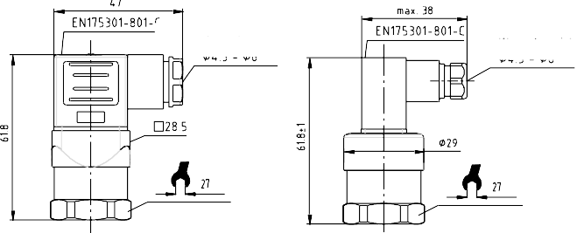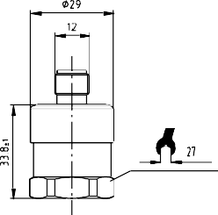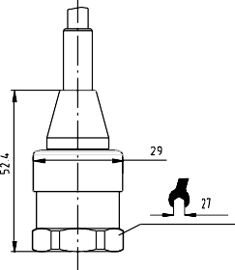
A
clamping range
clamping range

Pressure connections
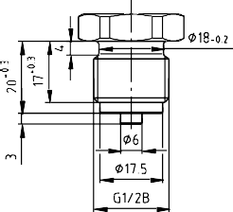
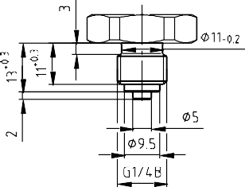
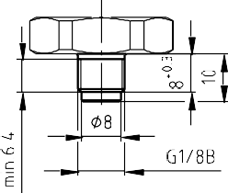
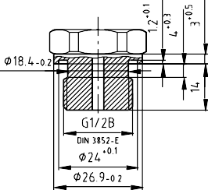
G 1/2 B G 1/4 B G 1/8 B G 1/2 DIN 3852-E

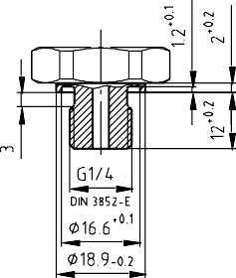
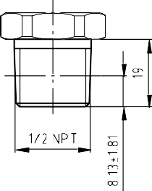
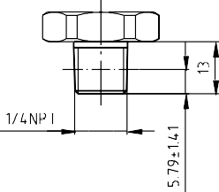
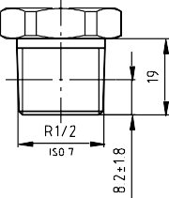
G 1/4 A DIN 3852-E 1/2 NPT 1/4 NPT R 1/2

R 3/8 R 1/4 G 1/4 female 1/4 NPT female
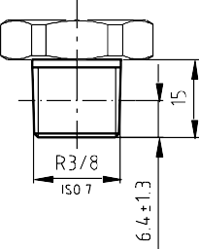
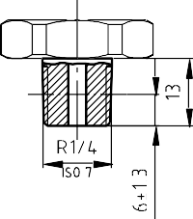
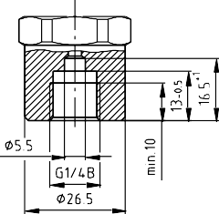
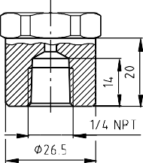
M20 x 1,5
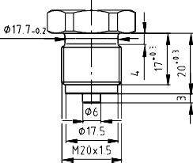

Electrical connector

Two-wire system
Connector according to DIN EN 175301-803 Form A with junction box

Connector according to DIN EN 175301-803 Form C with junction box

UB / S+
1
3
2
0V / S-
UB / S+
1
3
2
0V / S-

E-001
E-005

Circular plug-in connector M12x1 Cable outlet
braun
UB / S+
4 3
1 2

0V / S-
UB / S+
brown
0V / S-
blue

E-033

E-015
blau

Three-wire system
Connector according to DIN EN 175301-803 Form A with junction box

Connector according to DIN EN 175301-803 Form C with junction box

UB
S+

0V / S-
UB
S+
0V / S-

E-002 E-006

Circular plug-in connector M12x1 Cable outlet
braun
UB
S+

4 3
1 2

0V / S-
UB
brown
S+ black
0V
blue

E-034

E-017
/ S- grün
schwarz
blau

Modifications reserved

