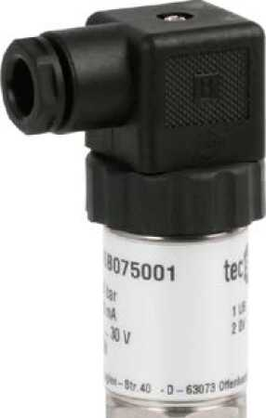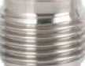

Technologies for Sensors Indicators and Systems I Force I Pressure I Temperature I Switch

Pressure sensors for general application

**with internal diaphragm**

**for gauge pressure and absolute pressure**

**Accuracy 0.25% and 0.5%**

**Standard output: 4 ... 20 mA; 2-wire**

**or 0 ... 5 VDC; 3-wire**

**or 0 ... 10 VDC; 3-wire**



Description

Pressure sensors for general application are top of the range pressure transducers.

Their accuracy, reliability, resistance to corrosion and mechanical load make them suitable for all pressure measuring tasks - in production, development or in the laboratory.

The measuring ranges, graded in accordance with EN, range from 25 mbar to the maximum pressure range of 1000 bar. The case and wetted parts comprise stainless steel and are thus resistant to chemically aggressive media. The pressure connection and measuring element are welded together, making the measuring system particularly resistant to mechanical shock or vibration.

For more difficult measuring tasks (e.g. hydrostatic column), two potentiometers enable the zero point and measuring range to be set.

The pressure sensors for general application meet the electronic magnetic compatibility (EMC) requirements to EN 61 326.

Features

o Measuring ranges from 25 mbar to 1000 bar

o Finely graded selection of nominal ranges according to EN

o Corrosion resistant, stainless steel design

o High overload protection

o Highly resistant to shock and vibration

o For dynamic or static measurements

o Good reproducibility

o Simple installation

Measuring Ranges

Gauge pressure

Negative -1... 0 bar to - 0.025 ...0 bar

Positive 0 ... 0.025 barto 0 ... 1000 bar

Absolute pressure 0 ... 0.25 bar to 0 ... 16 bar

Applications

Development and laboratory, process engineering, plant and apparatus construction, hydraulics and pneumatics

**Models: P3276**

tecsis GmbH Carl-Legien Str. 40-44 D-63073 Offenbach / Main Tel: +49(0) 69/5806-0

Sales National

Fax: +49(0) 69/5806-7788

Sales International

Fax: +49(0) 69/5806-7788

e-Mail: [info@tecsis.de](mailto:info@tecsis.de)

Internet: [www.tecsis.de](http://www.tecsis.de)

DE 700 m 03/2013

Technical data

|  |  |  |  |  |
| --- | --- | --- | --- | --- |
| **Model** | **P3276** | | | **Option** |
| Pressure type | negative or positive g auge p ressure | | absolute pressure | negative or positive gauge e |
| Output signal | 4 ... 20 mA - 2-wire  0. . . 5 VDC - 3-wire  0. . . 10 VDC - 3-wire | | | other signals on request |
| Accuracy % of F. S.') | 0.5 0.25  *0.25% BFSL 0.13% BFSL* | 0.5 0.25  *0.25% BFSL 0.13% BFSL* | 0.5 0.25  *0.25% BFSL 0.13% BFSL* |  |
| Ranges accord, to EN | 0. . .0.1 bar to  0 . .. 25 bar | 0... 40 bar to  0 . . . 1000 bar | 0 ... 25 bar to  0 ... 16 bar | 0. . .25mbard,  0... 40 mbar  0... 60 mbar |
| Sensor element | piezoresistive | Thin film | piezoresistive |  |
| Non-linearity | < ± 0.2% of F. S. | | |
| Non-repeatability | < ±0.1%of F. S. | | |
| Stability (annual) | < ± 0.2% of F. S. in reference conditions | | |
| Case | Stainless steel | | |
| Pressure connection 勺 | G 1/2 B to EN837 | | | G 1/4 B; 1/4 NPT; 1/2 NPT |
| Wetted parts | Stainleso steel | | |  |
| Overload limit | < 16 bar 3.5 x; < 600 bar 2x; > 600 bar 1.5 x; | | |
| Electrical connection | plug according to DIN EN 175301 -803 form A with junction box round connector M12x1; 4-pin | | | cable outlet with 1 m cable |
| Power supply | 10. . .30 VDC (14. . .30VDC for output 0 ... 10 V) | | |  |
| Power consumption | current output 4 ... 20 mA: signal currency voltage output: 8 mA | | |
| for output (0) 4 ... 20 mA Load | **UB-10V**  < for output 4...20 mA two wire  **0,020A**   * 5 kOhm for output 0 ... 5 V * 10 kOhm for output 0 ... 10 V | | |
| Temp, com pens, range | 0 ... 80 °C | | |
| Temperature influence -Zero point  -Measuring range | 土 0.2%/10 K 5) ±0.2%/10 K | | |
| Adjustability | zero point and full scale up to ± 5% | | |
| Response time | < 1 ms (within 10% to 90% of F. S.) | | |
| Protection type | IP 65 to EN 60 529/I EC 529 IP 67 to M12x1 connector | | | IP 67 / IP68 for cable outlet |
| CE-conformity &) -pressure equipment  Directive  EMC directive | 97/23/EC  2004/108/EEC, EN 61326 Emission (Group 1, Class B) and immunity (industrial location) | | |  |
| Electrical protection types | polarity, overload and short-circuit protection | | |
| Insulation voltage n | 500 VDC | | |
| Temperature ranges -Storage  -Medium  -Ambient | -40. . .100 °C  -30. . .100 °C  -20 . . . 80 °C | | | media temperature  -40 . . . 125 °C |
| Weight | approx. 0.2 kg | | |  |

of F.S. = full scale value

1. Including non linearity, hysteresis, zero point and full scale error (corresponds to error of measurement per I EC 61298-2)
2. 0.25% accuracy for ranges ^0.25 bar
3. For ranges < 0.1 bar: model P3275; technical data as model P3276;

wetted parts 1.4571, Si, Al and Au; only applicable for dry and non aggressive gases

1. 0 ... 2500 bar M16x1.5 female
2. <± 0.4 %/10 K for measuring ranges 0 ... 0.1 and 0 ... 0.16 bar
3. Declaration of conformity on request
4. NEC Class 02 power supply (low voltage and low current max. 100 VA even under fault conditions)

DE 700 m

Dimensions

Case

plug according to DIN EN 175301-803 form A with junction box

Accuracy 0.5%

Accuracy 0.25%

cable outlet

goL XTOE

Pressure connections

G 1/2B

B

M

^1

G

High pressure connection  
M16x1.5 female

CO'

G1/2

Screw-in aperture according to

G 1/2

DIN 16 288

G 1/4

High pressure connection  
M16x1.5 female

|~T』0.1|A|

(DIN 16288)

DE 700 m

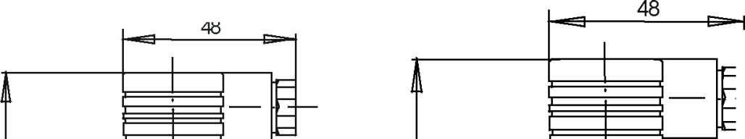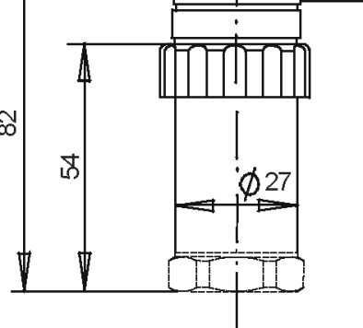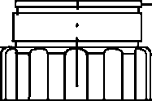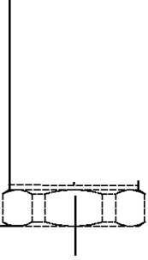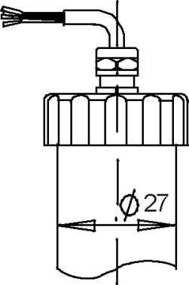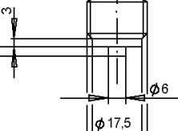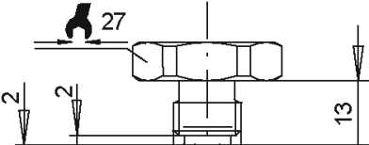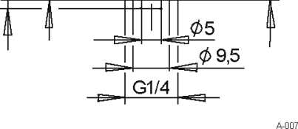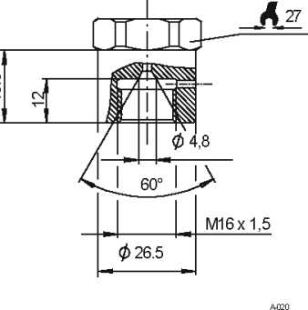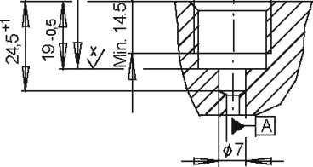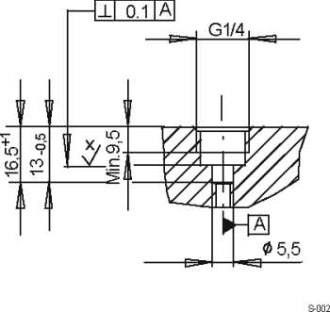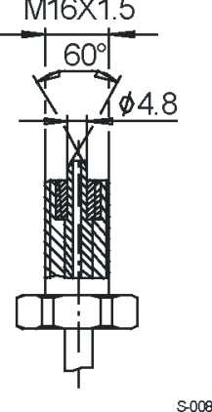

Electrical connection

Two-wire system

plug according to DIN EN 175301 -803 form A with junction box

E-001

MIL-plug

E-011

cable outlet

M12x1

**brown**

**green**

E-015

Three-wire system

plug according to DIN EN 175301 -803 form A with junction box

MIL-plug

E-012

M12x1

cable outlet

E-017

UB

**S+**

ov/s-

Connection table for DIN plug or cable outlet

|  |  |  |  |  |
| --- | --- | --- | --- | --- |
|  | 4... 20 mA  (2-wire) | | 0. ..10VDC  (3-wire) | |
| Supply: UB+ | 1 | brown | 1 | brown |
| Supply: 0V | 2 | green | 2 | green |
| Signal: S+ | — | — | 3 | white |
| Signal: | — | — | 2 | green |

DE 700 m

E-034

Order details

1. Model
2. Measuring range
3. Output signal
4. Options

Modifications reserved

